Pre-requisites

Hands-on Lab Step-by-Step

June 2020

# Lab Overview and Pre-requisites

## Abstract and Learning Objectives

This is a beginner level lab for you to get hands on experience with the [Microsoft Power Platform](https://dynamics.microsoft.com/en-us/microsoft-power-platform/) technologies. The lab includes step-by-step instructions for someone new to these technologies to build an event management solution in about an hour. Technologies covered:

**Power Apps**: A software as a service application platform that enables power users in line of business roles to easily build and deploy custom business apps. You will learn how to build both Canvas and Model-driven style of apps.

**Common Data Service** (CDS): Make it easier to bring your data together and quickly create powerful apps using a compliant and scalable data service and app platform that’s integrated into PowerApps.

**Business Card Reader:** The business card reader component takes a photo or loads an image from the local device, and then scans it to find a business card. If it detects a business card, it extracts the information it finds.

**Power Apps Portal:** low-code, responsive websites which allow external users to interact with the data stored in the Common Data Service.

Make sure to follow all the pre-requisite steps listed in this document before starting the labs.

## Pre-requisites: Before starting the hands-on lab

#### Task 1: Download the Lab Files – <http://aka.ms/appin60mins>

1. **Save a local copy of the lab contents:** Downloadthe **PAHandsOnLabContent.zip** file for the lab from **<http://aka.ms/appin60mins>**. Save it to a local folder, such as C:\AppInAnHour. Extract the ZIP package. This package contains the sample data for the app, PDF copies of the lab manuals, and pre-built app packages.

#### Task 2: Sign-in to Power Apps

1. **Confirm that you are licensed to use PowerApps:** Go to <http://make.powerapps.com> and sign-in with your business or school account. This is the same as your Office 365 or Dynamics 365 login.
2. **Plan 2 Trial of Power Apps:** Usage of the Common Data Service requires a Power Apps license. Go to <https://powerapps.microsoft.com/pricing> to start a free 30-day trial. For more detailed information on signing up for a free trial, see [here](https://docs.microsoft.com/en-us/powerapps/maker/signup-for-powerapps). For information on signing up for a free community plan for individual use, see [here](https://docs.microsoft.com/en-us/powerapps/maker/dev-community-plan).

NOTE: This lab documentation assumes that you will use the web version of the Power Apps Studio, which will run in a browser: Microsoft Edge, Internet Explorer 11, Google Chrome, or Safari.

NOTE: If you are unable to sign-up for a Power Apps license using your organization credentials, you may provision a free Office365 trial tenant at <http://aka.ms/Office365E5Trial> . Use these credentials to sign up for a Power Apps Trial. *Make sure to assign the new Power Apps license to your user*.  
  
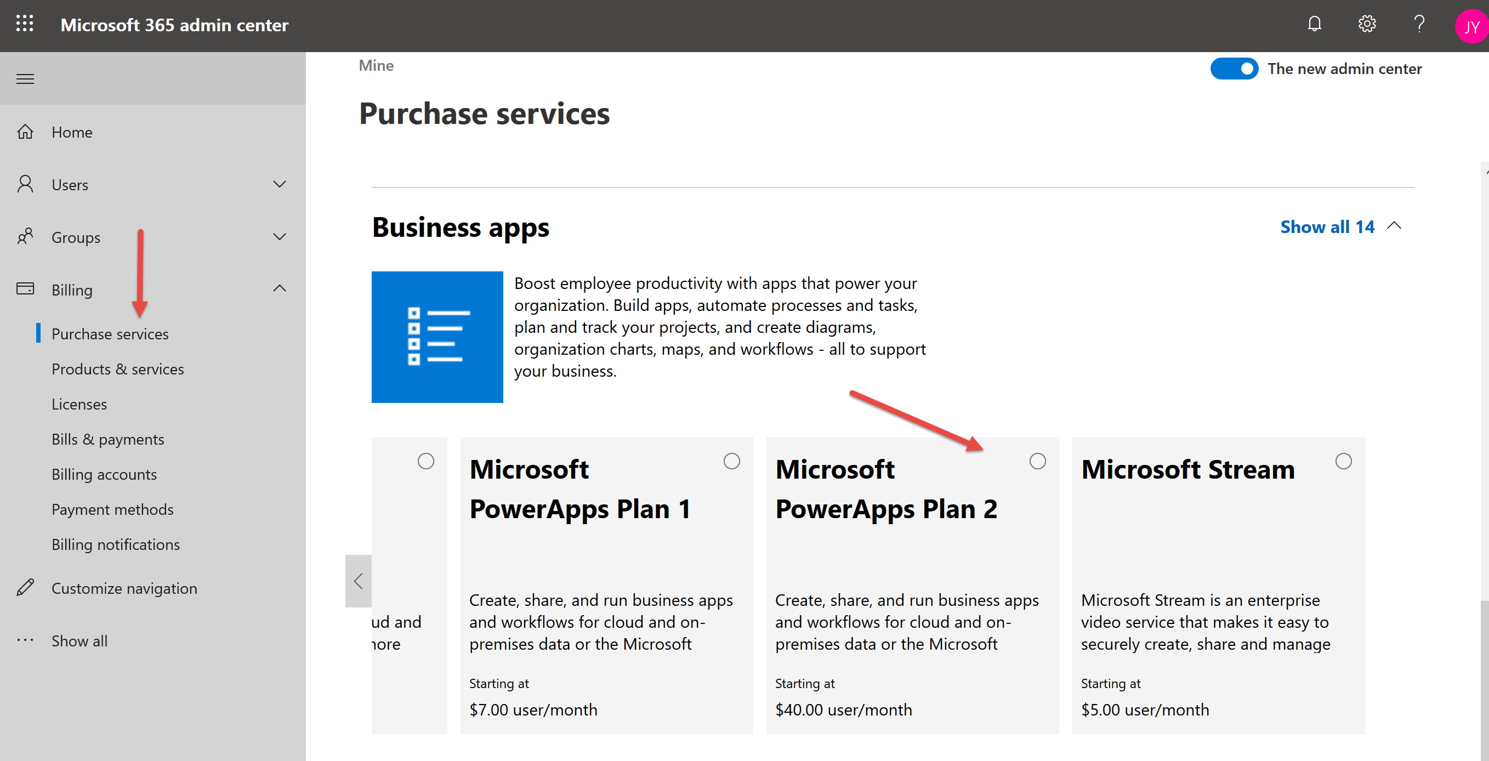

#### Task 3: Create a new environment and CDS for Apps database instance

You must have a newly created CDS for Apps environment and database instance.

1. Open the PowerApps admin center by navigating to <https://admin.powerplatform.microsoft.com> in a web browser.
2. You may be prompted to sign up for a free Power Apps trial if you did not already complete this as part of a previous step. Follow the prompts to start your trial, which will give you access to the admin center.

**Note**: you can also access the admin center by signing in at <http://make.powerapps.com> and clicking the settings icon in the top right and selecting **Admin center.**

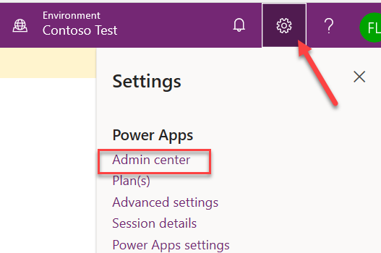

1. In the Admin center, select **Environments** and click **+New**.

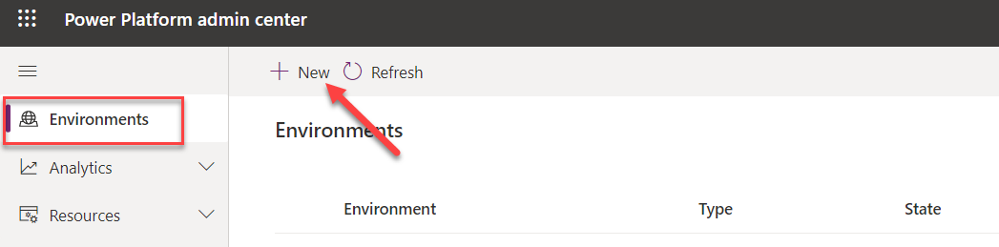

1. Provide a name for the environment**.** A common practice is to use your name followed by “Test” so it is clear this is a test environment.

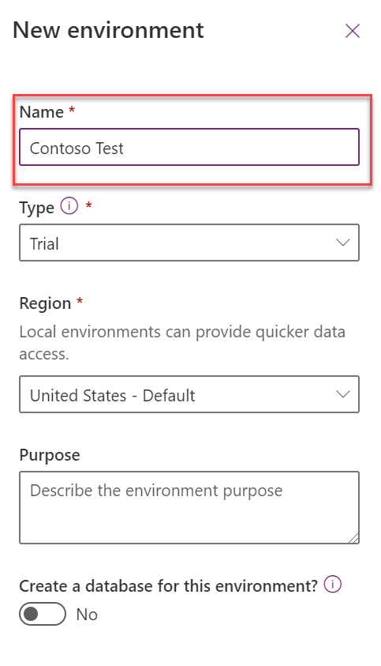

1. Switch **Create a database for this environment** to **yes** and click **Next**

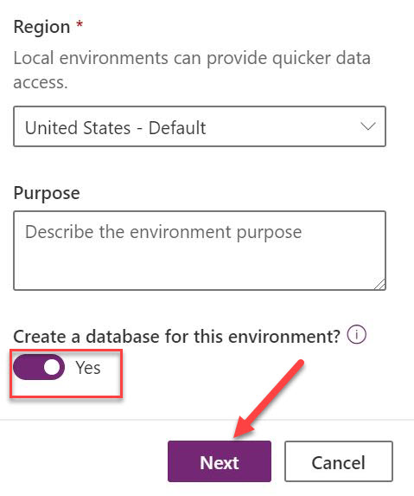

1. Select your **Currency, Language**, and make sure that **Deploy sample apps and data** is set to **yes.** Then, click **save.**

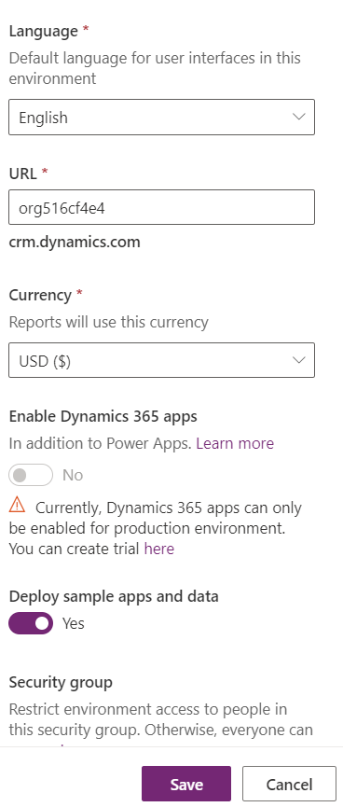

1. You will see a screen listing all environments that will show the newly created environment.

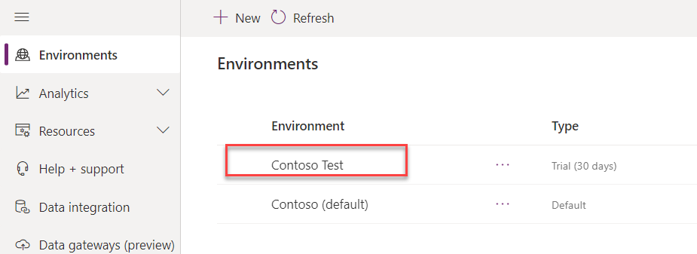

1. **IMPORTANT**: You need to wait for the database to finish provisioning before trying to create an application; the state will change to **Ready** when it is ready.

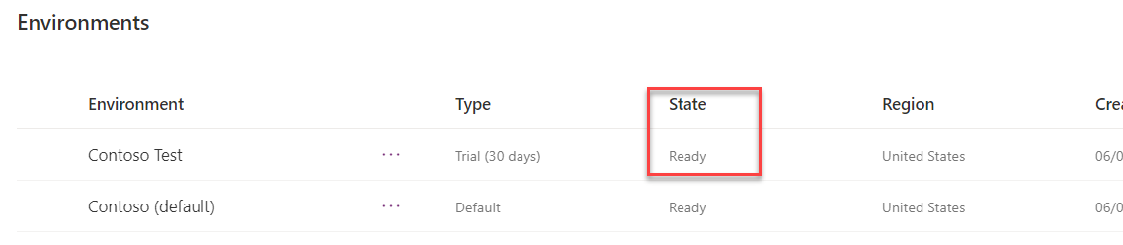

1. This may take a few minutes to complete. Wait for it to complete before proceeding with creating an app. If it has been over two minutes, try refreshing the browser. Once the database has been created you should no longer see this “Provisioning database” message. You can then proceed with the lab.

## Lab survey

Once you’ve completed the lab, we would appreciate your feedback on: both the product technologies that you learned about today – PowerApps, Common Data Service, Power Automate, AI Builder and on the lab content – the value of the learning experience and the quality of the documentation.

Please use the survey at [**https://aka.ms/AppIn60MinSurvey**](https://aka.ms/AppIn60MinSurvey) to share your feedback.

You may provide feedback for all modules at once, or as you complete each module. Thank you!

Information in this document, including URL and other Internet Web site references, is subject to change without notice. Unless otherwise noted, the example companies, organizations, products, domain names, e-mail addresses, logos, people, places, and events depicted herein are fictitious, and no association with any real company, organization, product, domain name, e-mail address, logo, person, place or event is intended or should be inferred. Complying with all applicable copyright laws is the responsibility of the user. Without limiting the rights under copyright, no part of this document may be reproduced, stored in or introduced into a retrieval system, or transmitted in any form or by any means (electronic, mechanical, photocopying, recording, or otherwise), or for any purpose, without the express written permission of Microsoft Corporation.

Microsoft may have patents, patent applications, trademarks, copyrights, or other intellectual property rights covering subject matter in this document. Except as expressly provided in any written license agreement from Microsoft, the furnishing of this document does not give you any license to these patents, trademarks, copyrights, or other intellectual property.

The names of manufacturers, products, or URLs are provided for informational purposes only and Microsoft makes no representations and warranties, either expressed, implied, or statutory, regarding these manufacturers or the use of the products with any Microsoft technologies. The inclusion of a manufacturer or product does not imply endorsement of Microsoft of the manufacturer or product. Links may be provided to third party sites. Such sites are not under the control of Microsoft and Microsoft is not responsible for the contents of any linked site or any link contained in a linked site, or any changes or updates to such sites. Microsoft is not responsible for webcasting or any other form of transmission received from any linked site. Microsoft is providing these links to you only as a convenience, and the inclusion of any link does not imply endorsement of Microsoft of the site or the products contained therein.

© 2020 Microsoft Corporation. All rights reserved.

Microsoft and the trademarks listed at https://www.microsoft.com/en-us/legal/intellectualproperty/Trademarks/Usage/General.aspx are trademarks of the Microsoft group of companies. All other trademarks are property of their respective owners.